Parent
Handbook
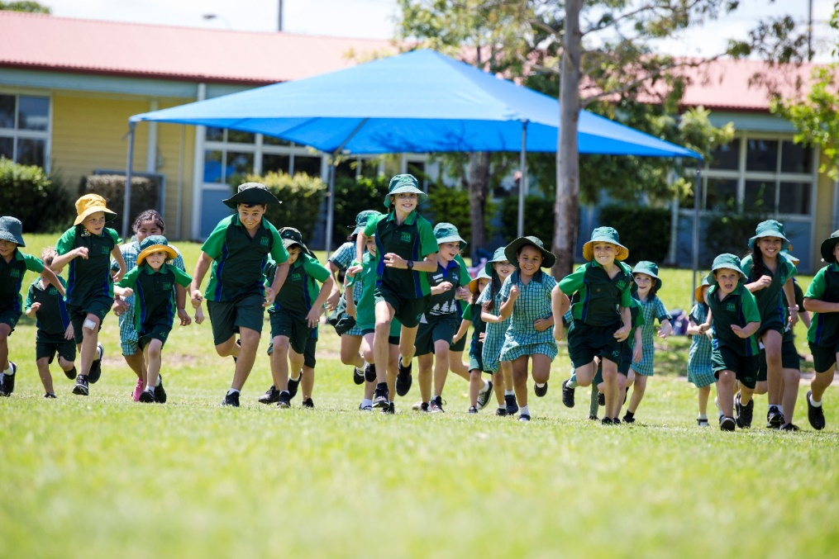

2023

SCHOOL INFORMATION

School: MORETON DOWNS STATE SCHOOL
Parsons Boulevard
Deception Bay 4508

Phone No: 38972666 Fax No.: 38972600

Email: principal@moredownsss.eq.edu.au

Web Site: www.moredownsss.eq.edu.au

Facebook: https://www.facebook.com/MoretonDownSS

School OPERATIONS

Hours of School

8:55am to 3:00pm

Sessions

The school day includes three sessions:

Session 1 8:55am – 11:00am
First Break 11:00am – 11:45am
Session 2 11:45am – 1:45pm
Second Break 1:45pm – 2:15pm
Session 3 2:15pm – 3:00pm

All pupils should be at school no earlier than 8.30am.

Principal’s Welcome
Thank you for considering Moreton Downs State School as the school for your children to learn and grow. Our school has, since opening in 1995 built a well-earned reputation as a school of quality, which works in partnerships with families to ensure their children reach their full potential.

School Vision
Empowering active learners, growing and achieving together.

School Values
Connecting: We are committed to creating positive, supportive relationships.
Innovating: Innovation and inquiry is an integral part of our teaching and learning.
Growing: We celebrate growth and development, encouraging everyone to reach their potential.
Discovering: We are committed to providing rich and diverse opportunities, within and beyond the classroom.

Absences
- If your child is to be absent for any reason, please phone before school and follow the prompt to leave a message (child’s name, class and reason for absence). Messages will be passed on to class teachers each morning. All absences must be explained under the Education Act. Should a student be absent for three days without notification, parents/caregivers will be contacted. To assist the monitoring of attendance the school uses an automated attendance SMS messaging service. All students not at school for the day will have their parents/caregivers sent a message advising of their absence. Parents/caregivers are requested to respond to these SMS’s with an explanation of the child’s absence.

Animals on School Grounds
Animals are not permitted on school grounds without prior arrangements with the school principal.

Arriving at School
Students should aim to arrive at school around 8:30am each day. Students who arrive before this time should go directly to one of the parents/caregivers drop off zones in the undercover areas (junior undercover, A or D) and sit quietly. Students will be supervised in the covered areas by staff from 8:20am. After the bell is rung (approximately 8:45am) students to move to classes.
- There is no play before school, including the school play equipment being out of bounds. This ensures students are calm and settled on entry to class in the morning and ready for the important first session of the day.
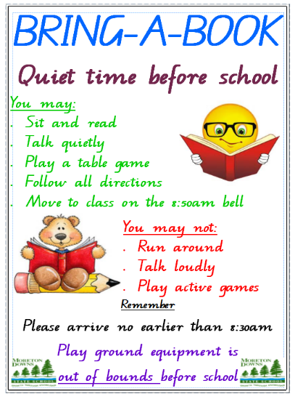
- Arrival and departure are via the front gates on Parsons Boulevard.
- All school gates, except the staff car park and the front main gate, are locked from 9:15am.
- The school front gate is closed from 9:15am but not locked.
- So that students may focus on their learning, parents/caregivers are encouraged to leave the school when the bell for class sounds.
Afternoon Departures
- Parents/caregivers arriving to collect children at the end of the day may enter the area and await their children in parent zone (junior undercover, D or A).
- Students are to leave school by 3.15pm, except when under the supervision of a teacher. After 3.15pm students need to be collected from the office.
- All students arriving later to school than 9:05am must receive a late note from the office on arrival.
- The school must be notified if children are to be picked up by any other person other than listed parents/caregivers.
- Early collection of children must occur through the office.

Assembly
Parents/caregivers are most welcome to attend the two whole school face to face school assemblies during the term. Assemblies provide opportunity for us to communicate with our students, recognise student achievement and provide an audience for students to showcase their work. Our virtual assembles in the other weeks of the term are held within the classroom.

Bell Times / Daily Routine
All schools need to run efficiently and at Moreton Downs State School we use a bell system. Key times are below:

Time | Description | bell
8:45 | Children Move to class | bell
8.55 | First Session Commences | bell
11:00 | First Break - Play Time | bell
11:24 | End of Play time - move straight to class to eat | bell
11:30 | Eating in Classroom | bell
11:45 | Second Session commences | bell
1:45 | Second Break Play time | bell
2:02 | End of Play time - move straight to class to eat | bell
2:05 | Eating in Classroom | bell
2:15 | Third session Commences | bell
3:00 | Classes Dismissed | bell

Book drop off
To alleviate some of the congestion on the first day back to school, a book drop off will be offered before commencement date.
A parent or carer with children in Years 1-6 will be able to drop off their child’s books to their classroom from 2:10pm – 4:00pm on the set date.
Booklists
Teachers have compiled all booklists and it is essential that students have the materials listed on the booklists. Booklists are designed for parents to order a complete set or to indicate those books and materials that are required. Parents are asked to check student requirements throughout the term to ensure students have all necessary equipment for their learning. A voluntary student resource scheme is used in Prep only for consumables.

The school uses a commercial provider (EDSCO) who can collate and deliver booklist items.

Brain Break
All classes participate in Brain Break at around 10:00 am each day for approximately 10 minutes. During this time students eat healthy food and drink water. Please make sure brain break food is limited to healthy food options (fruit, vegetables and water).

Calendar of Events / School Calendar
A calendar of school events is published at the beginning of each term on our website.
MDSS events-calendar

Incursions and excursions
Incursions and excursions are organised according to the school’s policy. Some incursions and excursions come at a cost to parents and several weeks’ notice is always provided. Excursions relate to curriculum focus areas.

Parents are advised early in the year of expected costs. Payment plans are provided, if you would like a payment plan, please contact the office well in advance of the due date for payment.

Car Parking
The school has substantial car parking. There is a designated area for staff only, inside the school grounds. All other parking should occur in a safe and careful manner in the designated areas. We ask all drivers to be aware of children when driving around our school.

Community Involvement-Volunteers
Volunteers must remember to sign in at the office. Parent participation is a significant feature of our school and we continue to encourage families to become involved in the educational lives of their children. We encourage volunteers to:
- Assist in tuckshop
- Assist with the P&C activities
- Assist in classes
- Assist with excursions and special events
- Join the various Parent Committees within the school e.g. P&C Association, Uniform Shop etc.
- Special event involvement

Complaint Management
Effective partnerships between parents/caregivers, students and our school are important to educational success. From time to time you may have concerns relating to your child or our school. We want to hear your concerns because it is only that way that we can resolve the issue. We aim to provide an educational service that can be improved through your feedback. You can raise an issue with any member of our staff but should do so in a respectful way.

Sometimes it is not possible to see you immediately, so we would ask that you make an appointment to meet with the relevant person or arrange a suitable time for them to phone you. We like to know what your concern is prior to the meeting so that information can be prepared if necessary. Further information can be found on our website by clicking the below link:

Concerns and Complaints Policy

Curriculum Overviews Term 1, 2, 3 and 4
Curriculum overviews provide comprehensive information about how our school: plans, delivers, assesses and reports on curriculum. The learning program at Moreton Downs State School covers all eight Key Learning Areas (KLAs) of the Australian Curriculum: English, Mathematics, Science, History, Geography, Languages Other Than English, The Arts, Health and Physical Education and Technology.

The school strives to provide all students with access to curriculum that caters for the learning needs of all students.

Dress Standards - wearing the School Uniform
On enrolment parents/caregivers receive a copy of the school ‘Dress Code Policy’.

Details of the uniform are:

UNIFORM DETAILS
Item / Event | Details
Polo Shirt (unisex) | Green polo shirt with school badge/logo.
Shorts (unisex) | Green shorts with badge/logo.
Options | Skorts or tunic dress with school badge/logo.
Sport Uniform  (Inter-house events) | Shirt - House shirt in each of the 4 house colours and printed with the house name.  Shorts/Skorts – Green school shorts with school badge/logo.  House shirts may also be worn on class HPE days.
Hats | Broad brimmed hats (green) are to be the worn for HPE and lunch play.
Socks | White socks. Socks must be seen above the shoe.
Shoes | Predominately black, enclosed leather or vinyl shoes or sports joggers.
Winter Options | Jacket (green), jumper (green), track pants (green).  Tights (black or green) may be worn, however shorts or skorts must be worn over tights.
Music Shirt | Students performing in any school band, ensemble or choir must wear a music shirt.  Students may choose to purchase one (ordered once each year), or borrow from the school stock.
Senior Shirts | Year 6 students may purchase a souvenir shirt in their senior year.
Out of school events | Students must wear the approved uniform (school, sport or music) for all out of school events.
Permitted Jewellery and Make-up includes: | - A watch  - Pierced ears only are permitted and ear rings must be small plain sleepers or studs — 1 pair  - Necklaces of religious significance may be worn but tucked under the shirt  - Medical alert bracelet or necklace  Students will be asked to remove / tape jewellery during sporting activities.  Make-up, fingernail polish and decorative jewellery is not to be worn at school.
Hair | Hair which is longer than shoulder length should be tied back from the face with bands, ribbons or scrunchies in the school colours.  Outlandish styles (including ‘tracks’) and unnatural colours (bleached or dyed) are not permitted.
Helmets | Students riding a bike or scooter to school are legally required to wear an approved helmet.

Early Education in Queensland
Prep education is now mandatory in Queensland schools. To be eligible to enrol your child in the preparatory year, children must be 5 by 30 June in the year they begin prep. Please feel free to contact the school should you require further information.

Enrolment Management Policy
An ‘Enrolment Management Policy’ applies for Moreton Downs State School. Only students residing in the designated catchment are guaranteed enrolment. All other students intending to enrol are placed on a waiting list. A catchment map can be found on our website.

Emergency Procedures-Evacuation and Lockdown
The school has documented procedures for emergency situations. These are practised each term with teachers explaining processes to students before the practice. If the school is in evacuation or lockdown parents/caregivers must remain outside the school grounds. During these times children are under the direction of their teacher and will not be released to parents/caregivers. Parents/caregivers will be notified of any emergent situation.

Extra Curricula Opportunities
Through the commitment of staff, and supported by parents/caregivers and members of the wider Moreton Downs community, our school offers a wide range of extra opportunities for students at our school. Some of these are:
- Instrumental Music Years 3-6 (See Student Resource Scheme for care and maintenance of borrowed instruments)
- Recorder Band
- Mosaic
- Choirs
- Interschool Sport
- Drama and Dance Groups
- Student Council
- Swimming Years 1-6
- A range of extra sporting events

Facilities
Through the extensive co-operation of the school community, and significant government investment in recent years, our school boasts quality educational facilities for our students. We are continuously seeking to improve physical environment both inside and outside the classrooms through applying for grants and holding working bees, fundraising etc.

Head Lice
All parents/caregivers have an obligation to check children’s hair regularly for lice and / or eggs, treating as necessary. Regular checks and follow-up treatment are necessary. Information about treating head lice can be found at below website: Head-lice

Health Advice
Further information on recommended exclusion periods for infectious conditions can be found at the below website:
Health Advice

Interschool Sporting Teams
Our school participates in two, 8-week interschool sport periods during the year. Teams are selected and coached at school. Parent permission in writing is required for selected students to attend. Interschool sporting teams may have specific uniform requirements. This will be advised by the team coach.

Lost Property
Property that is found around the school is placed in containers outside the office. Each week, clothing is sorted and labelled and property is returned to owners. Note: Mark clearly all items of clothing and personal property with child’s name.

Medication
Where prescribed medication is required to be administered whilst the student is at school or involved in school related activities, a caregiver must complete a form at the office including medical advice. All medication must have a pharmacy label which clearly indicates dosing quantities, times and the student’s name. Where medication is to be administered or dosage changed, the instructions must be provided by the medical practitioner or by a pharmacist in writing.

Staff record any administration of medication.

Students who have a ‘Health Management Plan’ must have a plan provided by a doctor and reviewed annually. ‘Health Management Plans’ of a parent or caregiver are not acceptable. Medication may be held at the school for use during a particular emergency eg. asthma, diabetes, anaphylaxis, epilepsy and other potentially serious conditions. Based on diagnosed students' needs, ongoing health monitoring is supported by an EQ nurse who trains school staff in the areas of suctioning, catheterization/toileting plans and tube feeding. Support for a temporary injury such as broken bones/head injuries require a letter from a medical practitioner.

School personnel provide basic first aid for injuries.

Students are not to attend school if unwell with cold and flu symptoms. In the event of a health management need, parents/carers must be able to be contacted. Please check that the office has the correct contact details, including emergency contacts.

Mobile Phones / iPods / Digital devices
We understand and respect that parents/caregivers may provide their children with phones for security and transportation information reasons outside of school time however, students are not permitted to have access to their phones when inside the school gate, unless they are at the office.

Mobile phones/digital devices are prime targets for theft and hence, any student who chooses to bring these items to school will do so at their own risk.

In line with Department of Education recommendations, this school’s policy on mobile phones is:
- Students must hand their mobile phone/digital device to office staff before school starts and pick it up again at the end of the school day.
- If there is a need to contact your child during the day then contact must be made via the school office on 3897 2666. Messages will be passed to your child.

Newsletters
Our school provides a fortnightly newsletter digitally. It can be sent to an email address or mobile phone. We also link the newsletter to our Facebook page and our website. MDSS newsletters MDSS Facebook

Parents and Citizens Association & Sub Committees
An active involved Parents and Citizens’ Association serves the school community and it follows the basic aim of promoting quality education for all children. The Parents and Citizens’ Association operates sub-committees such as the: Tuckshop, Uniform Shop and Fund Raising, as well as special events.

Monthly meetings are held on the third Wednesday at 6.30pm in the school library. Notice of meetings is advertised in the school newsletter and on our social media pages.

Parent/Teacher Conferences
Parent teacher conferences are scheduled twice a year in term 1 and term 3. They are a vital communication tool within our school which provides a platform to establish open communications between teacher and parents/caregivers.

Payment for incursions, excursions and other school related expenses
Moreton Downs State School has ‘EFTPOS’ facilities to assist with all payments. We ask parents/caregivers to utilise this facility. If there is a genuine concern with payment for activities please contact our Business Services Manager to organise a payment plan.

Refund Guidelines for Excursions and Camps
Parents may request a refund for an excursion, incursion or camp by completing the Request for Refund form available from the school office.
The decision as to whether the school will or not refund the payment in part or in full depends on whether the school has incurred any costs associated with the activity. Where possible, we prefer to credit the refundable amount against the student’s account at the school, and use it to offset any future charges.

Department of Education policy references:
Department of Education (General Provisions) Act 2006
User charging procedure
Student resource scheme

Religious Instruction
Non-denominational classes are conducted weekly by volunteers from various religious denominations. A Christian strand is the basis of all programs which follow Department of Education guidelines. This is discussed at the enrolment interview.

Reporting on Student Progress
Parents/caregivers are provided written report cards twice each year.

School Watch Program
School Watch is a security program, designed to encourage staff, students and members of the general community to be more observant of suspicious behaviour in school grounds out of hours and be prepared to report it to authorities. If you see any suspicious behaviour in our school please phone 13 1788.

Senior Leadership badge
In year 6 students can apply for their senior leadership badge.

Smoking
Our school observes a strict no smoking policy in all parts of our school site. Parents/caregivers are requested to refrain from smoking near collection points also, providing good models for our students. A six-metre exclusion zone exists around schools.

Special Education Program (HIVE)
At Moreton Downs State School, our support is inclusive, which means, that support is delivered as much as possible in the classroom. Ultimately, that is where all students belong, with other children learning together.

Support at school begins with students feeling welcome at school and being happy to learn. Support at Moreton Downs State School is based on three layers:

Layer One – occurs in class, with adjustments made by the class teacher. Most support occurs in class. In Prep, we have Speech Language Pathologists and an Occupational Therapist who work closely with teachers to support the important foundation and developmental skills. They also support all other year levels.

Layer Two – students receive some re-teaching of concepts / skills either by a teacher or teacher aide, directed by class teacher or support staff.

Layer Three – students with high needs receive layers one and two and have all their work and/or materials adjusted for them to have access to learning at their level on the same basis as their peers. Our support team is called the HIVE. We have highly trained Inclusion Teachers who work with class teachers and students with support needs across the school. Student support and adjustments are documented in a Personalised Learning Plan. Students who are verified are support managed by the HIVE, including Autism, Speech Language Impairment, Hearing Impairment, Vision Impairment, Physical Impairment and Intellectual Disability.

Student Code of Conduct
A copy of our Student Code of Conduct is available to each parent on enrolment. It is important that all parents/caregivers read and understand this plan. The plan outlines the processes we use to manage all student behaviour. The plan is based on the principles of Positive Behaviour for Learning (PBL) and is a consistent approach to managing student behaviour. Please approach our school leadership team if you have any questions or refer to a copy of our Student Code of Conduct on our website. MDSS Student Code of Conduct

Support Available
In Prep, our school screens hearing, vision and speech language. Students across the school have access to screening and learning assessments as required. A weekly referral meeting occurs so class teachers can refer a student of concern after layers one and two have been implemented. We have a Guidance Officer part-time, who is able to conduct learning assessments to further support targeted learning. Our Guidance Officer works closely with HIVE staff to support high learning, social and emotional needs of children and families, including Children in Care. Our school has access to external services to support families. A Red Cross Support Worker is based at school for one day a week, a psychologist delivers therapy to specific students / families and if agreed by families, we refer to external agencies for home-based support. We work closely with advisory staff at times from Autism Queensland, Hearing, Vision, Urban Indigenous Health Support and Health Management / Medical staff.

Specialised Programs and Specialist Teachers in the following areas:
- Languages – Japanese for Years 4/5/6
- HPE
- Music
- Design and Technologies
- Digital Technology

Sport Program
Inter-school and Inter-house activities are features of the sports program which is a component of the Health & Physical Education Program. Inter-school sports will be offered in Term 1-2 and 3-4 for Years 5/6 students.
Sporting Houses
Upon enrolment all students are placed in house teams. These houses are used throughout the school for a variety of purposes, including Inter-house sporting activities.

The sports houses are: Freeman-Red, Meninga-Gold, Norman-Green, Perkins-Blue

Student Leadership
Each year a school leadership team (4 Students) is elected in term 4 of the preceding year from our year 5 students. These students then represent the school at various times during the year and also assist with other tasks around the School. Students are also elected for our school houses, voice, music and STEM.

Student Resource Scheme (SRS)
Please refer the Student Resource Scheme procedure for information on the SRS refunds.
For more information please contact school office or email admin@moredownsss.eq.edu.au. Department of Education (General Provisions) Act 2006 Student Resource Scheme

Music SRS
Moreton Downs State School operates an SRS for the hire of musical equipment. The scheme is supported and approved by the school’s P & C Association and operates under the policy and guidelines of The Department of Education (DoE).
The SRS is voluntary and provides parent/caregiver with a cost effective and more economical alternative to purchasing musical equipment. If you do not wish to join the scheme you are responsible for providing your child with the appropriate musical instrument to enable their participation in the music program. Any Surplus funds remaining go towards the purchase of new instruments

Prep SRS
Moreton Downs SS operates a Prep SRS to assist parents with the cost and resourcing of additional educational requirements that provide enhanced learning opportunities. The scheme is NOT used to raise funds for other purposes. The scheme is supported and approved by the school’s P & C Association and operates under the policy and guidelines of The Department of Education (DoE). The SRS is voluntary and provides parent/caregiver with a cost effective and more economical alternative to purchasing required resources and consumables through reduced prices gained from the school’s bulk purchasing processes. If you do not wish to join the scheme you are responsible for providing your child with the year level class requisites as detailed in the Prep SRS booklet.

Year 5 SRS
Moreton Downs SS operates a Year 5 SRS to assist parents with the cost of laptop computers. The scheme is NOT used to raise funds for other purposes. The scheme is supported and approved by the school’s P & C Association and operates under the policy and guidelines of The Department of Education (DoE). The SRS is voluntary and provides parent/caregiver with a cost effective and more economical alternative to purchasing laptop computers through reduced prices gained from the school’s bulk purchasing processes.

Trespassing / Security
Being on school property out of school hours without permission constitutes trespass. Police keep schools under surveillance out of hours in an attempt to reduce vandalism and wilful damage to school property. Parents/caregivers are asked to emphasise the above with their children so that they do not enter school grounds after school or at weekends. A private security firm patrols the premises out of school hours to enhance the security at the school.
A school watch program is active. Parents/caregivers and other community members are asked to contact 131 788 to report any concerns they see at the school out of hours.

Tuckshop
Tuckshop facilities are available four days a week (excluding Tuesday) from 8.30am. Regular news on tuckshop activities is included in the school's newsletter. A wide range of nutritious foods feature on the tuckshop menu to suit all tastes. Flexischools is our preferred method of ordering for students’ lunches. On line ordering steps:
- Go to www.flexischools.com.au
- Click REGISTER
- Enter your email address
- You will be emailed a link to an online form – follow the link
- Choose a username and password and complete the form
- Add each student and their class
- Top-up the account – VISA or Mastercard

Uniform Shop
Uniforms can be purchased through Flexischools. We aim for orders placed before 3pm on a Thursday to be delivered directly to your child’s classroom on Friday. If you are unable to use Flexischools, our uniform shop is available by appointment. Contact the tuckshop on 3897 2628 or alternatively contact the office on 3897 2666.

Visitors
To maintain safe practices and manage all those who are on site visitors to the school during school hours MUST sign in via the office.

